COURSE CODE/TITLE: | CPE 010 |  | SECTION: | CPE21S3
DATE PERFORMED: | 8/18/26 |  | DATE SUBMITTED: | 8/26/26
NAME: | Ralf Nicolo B. Abello |  | INSTRUCTOR: | Engr. Jimlord Quejado

ACTIVITY NO. 6.1 | Searching Techniques
1. PROCEDURE OUTPUT
Screenshot | 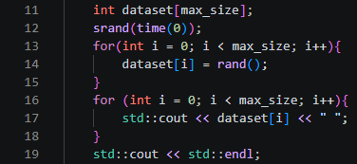
Observation | I used srand(time(0)) to seed rand() with the current time, so my dataset array fills with 50 different pseudo-random integers every time I run the program. Since I never bound the range with a modulo, the values span the full int range rand() allows.
Table 6-1. Data Generated and Observations.

Code | 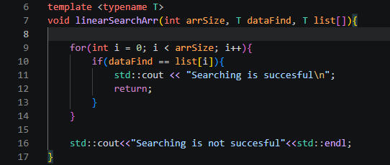  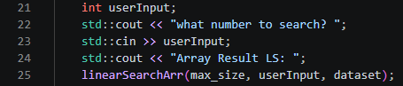
Output | 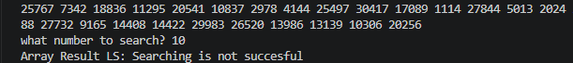
Observation | My linearSearchArr function is a template, so it works on any array type without me writing a separate version for int. It walks the dataset array from index 0 and stops the moment it finds a match, otherwise it checks all 50 elements and prints failure.
Table 6-2a. Linear Search for Arrays

Code | 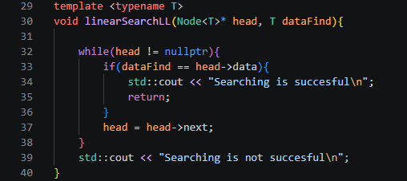  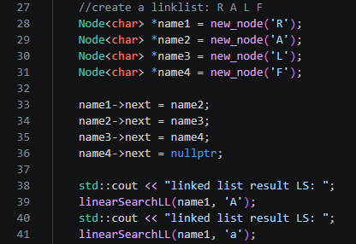
Output
Observation | My linked list holds the characters R, A, L, F connected through each Node's next pointer. Searching for 'A' succeeds since it's in the list, and searching for lowercase 'a' fails because the comparison is case-sensitive.
Table 6-2b. Linear Search for Linked List
Code | 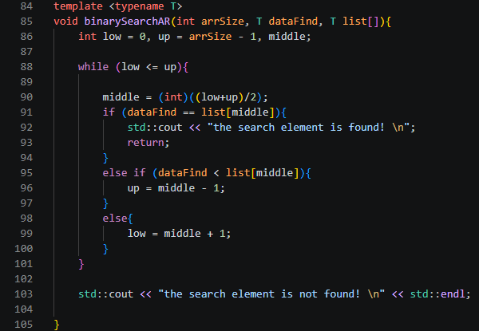  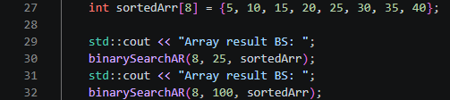
Output
Observation | I used binarySearchAR on the sortedArr array, which holds ascending values so the algorithm can correctly narrow the search range. Searching for 25 returns found because it sits at index 4, right where the midpoint calculations land on it as low and up converge. Searching for 100 returns not found since it's outside the range of values in sortedArr, so low eventually exceeds up and the loop exits without a match.
Table 6-3a. Binary Search for Arrays
Code | 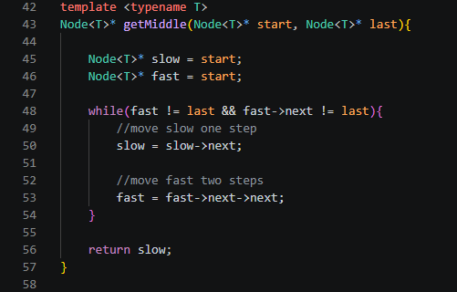  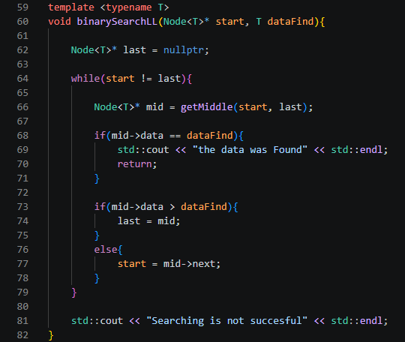  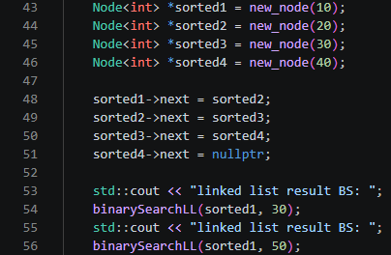
Output
Observation | My sorted1 through sorted4 nodes hold 10, 20, 30, 40 in ascending order, which binary search requires. getMiddle uses a slow/fast pointer pair to find the midpoint without needing an index, and binarySearchLL narrows the start/last window each iteration until it finds 30 or exhausts the list looking for 50.
Table 6-3b. Binary Search for Linked List

2. ANSWERS TO SUPPLEMENTAL ACTIVITY
Problem 1
Code | 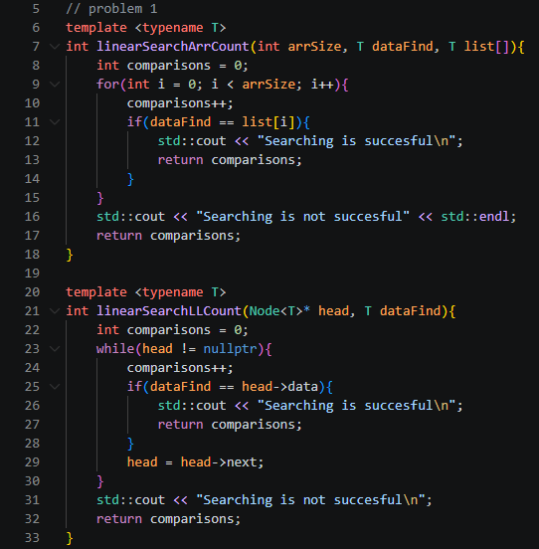  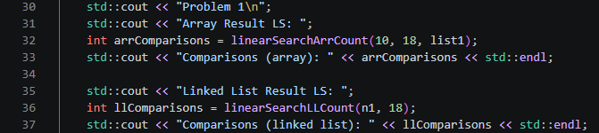
Output | 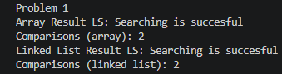
Answer | Both the array and linked list approach take 2 comparisons to find 18, since it's the second element in the list at index 1, and my comparisons counter increments once per element checked.

Problem 2
Code | 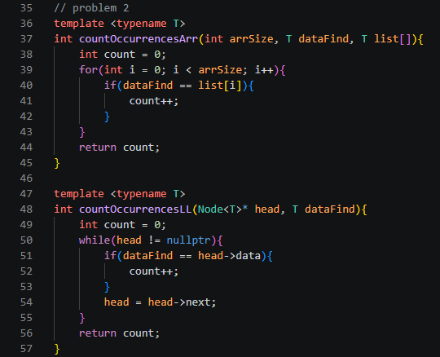  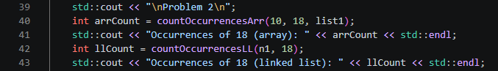
Output | 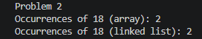
Answer | Instead of stopping at the first match, countOccurrencesArr and countOccurrencesLL scan the whole list and increment count every time they see 18. It appears at index 1 and index 4, so both return 2.

Problem 3
Diagram | 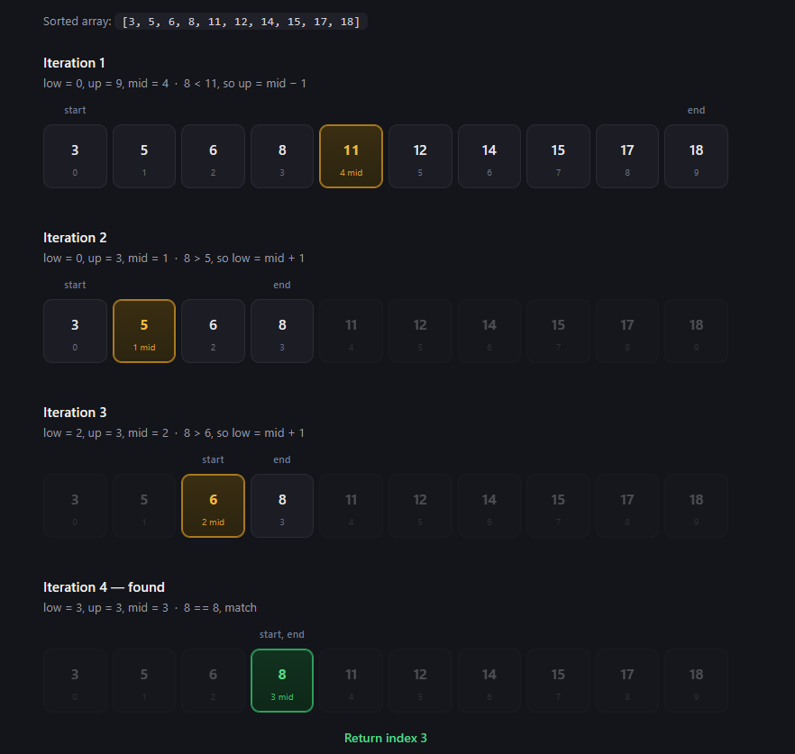
Code | 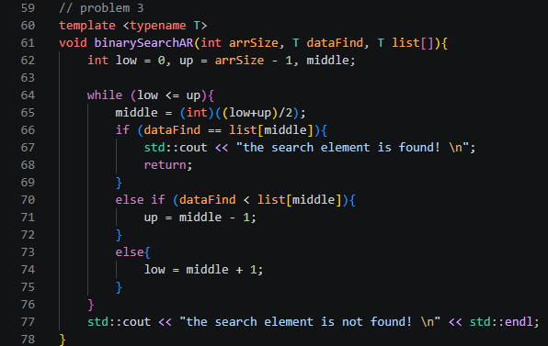  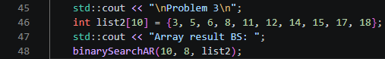
Output | 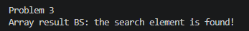
Answer | My diagram matches the actual code, binarySearchAR narrows low and up the same way I traced by hand and lands on index 3 after 4 iterations, confirming 8 is found.

Problem 4
Code | 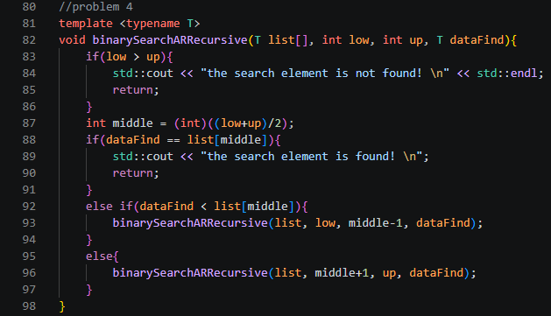  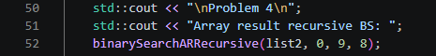
Output
Answer | I replaced the while loop from binarySearchAR with a self-call. Each call narrows low and up the same way, and instead of looping, binarySearchARRecursive calls itself with the new bounds, producing the same 4-step narrowing from problem 3 and landing on 8 at index 3.

Conclusion
In this activity I learned how sequential search checks elements one by one while binary search cuts the search space in half each time, but only works once the data is sorted, which is why I had to sort a copy of my array before calling binarySearchAR instead of running it directly on the random dataset. Going through the procedure showed me the difference between walking an array by index and walking a linked list by pointers, especially with getMiddle, which uses a slow and fast pointer instead of jumping to an index. The supplementary problems helped me more on understanding how algorithms work since I modified my own functions to count comparisons, count repeating instances, and convert binary search into a recursive version, which helped me actually see low, up, and mid narrow the same way whether the code loops or calls itself. Overall I think I did well in this activity since I was able to implement, test, and get correct output on every problem, and my area for improvement going forward is testing each function as I write it instead of waiting until the end to run everything together.

3. ARTIFICIAL INTELLIGENCE (AI) USE DISCLOSURE STATEMENT
I hereby declare that artificial intelligence (AI) tools were used, if applicable, in the preparation of this academic work. The following indicates the nature and extent of AI assistance:

Tools Used: | ChatGPT & Grammarly
Examples: ChatGPT, Microsoft Copilot, Grammarly, QuillBot, etc.

Purpose of Use: | Grammar Correction & Explanation of concepts
Examples: grammar correction, idea generation, formatting, summarization, code assistance, explanation of concepts, etc.

Extent of Use: | Explain how the concept works so I can implement it on my code
Explain how AI was used and confirm that it did not replace original thinking, analysis, authorship, or completion of the required work.

By submitting this activity, I affirm that my use of AI complies with T.I.P.’s AI usage policy and does not exceed the permitted limits for similarity, automated content generation, or academic assistance.

I understand that any false, incomplete, or misleading disclosure may be subject to investigation in accordance with due process and may result in sanctions for violation of existing T.I.P. policies.

Lab activities, templates, and related instructional materials shall not be reuploaded, reproduced, distributed, or shared with external organizations or third parties without the prior express written permission of the Technological Institute of the Philippines.

